**EPIC Project Summary**

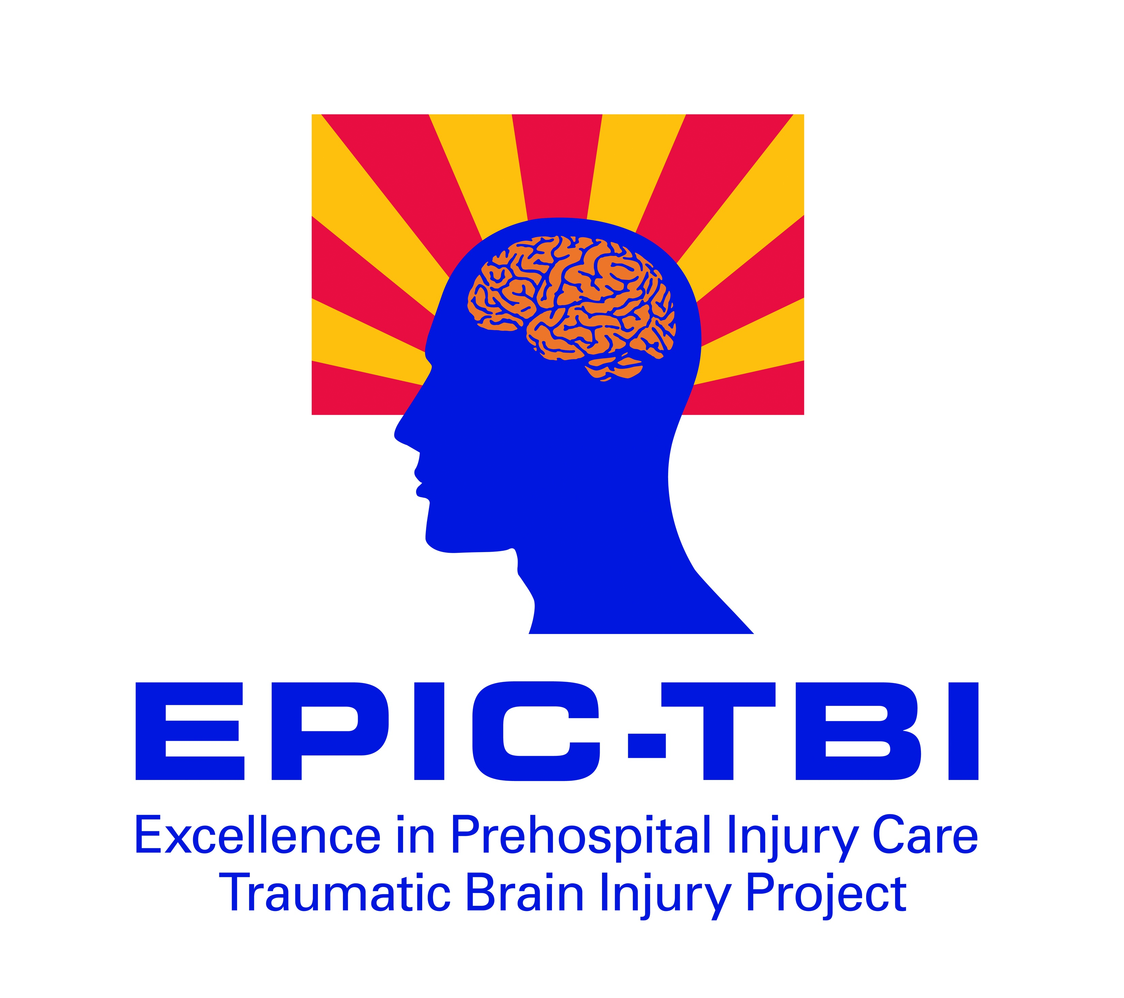  
**Significance**: Approximately 1.4 million victims of Traumatic Brain Injury (TBI) are seen in emergency departments each year in the U.S. and, of those, 50,000 die and 235,000 are hospitalized. A least 2% of the U.S. population has a TBI-related long-term need for help to perform activities of daily living. TBI is clearly a major public health problem. It is very encouraging that there is growing evidence that the management of TBI in the early minutes after injury profoundly impacts outcome. This has led to the promulgation of evidence-based prehospital TBI treatment guidelines by authoritative national and international scientific bodies. On surveying of EMS systems in Arizona and across the country, these TBI treatment guidelines have been implemented in a very few communities.

**What is the EPIC Project?**: EPIC stands for Excellence in Prehospital Injury Care and is a statewide collaboration between Arizona Fire Departments, ground and air EMS transport agencies, the University of Arizona and the Arizona Department of Health Services.

**Goal**:***The goal of the EPIC Project is to dramatically increase the number of severe TBI victims who survive with good neurologic outcome by thoroughly implementing the national EMS TBI guidelines.***

**Plan**: EPIC will utilize its EMS training team to help EMS agencies implement and measure the nationally-vetted TBI guidelines across a broad variety of EMS systems (urban, suburban and rural) throughout the State of Arizona. This will be accomplished through the existing statewide collaboration between the University of Arizona, the Arizona Department of Health Services, and local EMS agencies. This will mirror the approach that has been successfully employed to achieve a *tripling* of patient survival from out-of-hospital cardiac arrest in the state.

**Data Collection**: To evaluate the benefit from implementing the TBI guidelines, accurate data will be collected from participating EMS agencies. This data will be linked to Arizona State Trauma Registry (ASTR) data to show benefit to patient survival and other outcomes after TBI. Since EPIC is a statewide quality improvement initiative aimed at a public health problem (TBI), EPIC has been formally determined to be exempt from HIPAA.

Thank you for your interest in the EPIC Project.

**For more information, please contact:**

**Bruce Barnhart, RN, CEP**

**The University of Arizona**

[**BBarnhart@aemrc.arizona.edu**](mailto:BBarnhart@aemrc.arizona.edu)

**602.827.2140**

  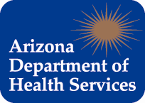 

In partnership with Arizona EMS Agencies